Nodejs

**Background**

An exchange may be a physical location where traders meet to conduct business or an electronic platform

In the most recent decade, trading has transitioned to fully electronic exchanges. Sophisticated algorithmic price matching can ensure fair trading without requiring all members to be physically present on a centralized trading floor.

You are going to create a part of this electronic trading specification as given below.

Create an order book in database that can store buy and sell orders

order {

Side: “buy”,

“Price”:”12.3”

}

order {

Side: “sell”,

“Price”:”12.3”

}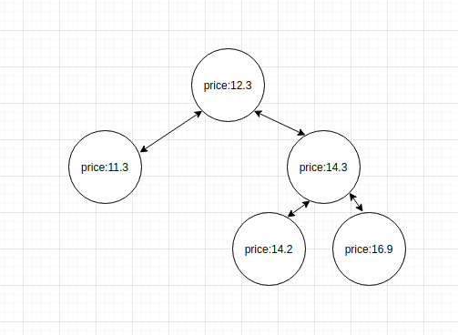

* Create a API to store a single buy and sell orders in database
* write code that listens for orders, when the user hits api, create a binary tree on it.
* if two prices match each other and the side does not match, the system should delete this transaction from db and from binary tree.
* Create a redis channel, when user hit api, send order information on redischannel, channel should listen and send this order to redis
* if two prices match each other and the side does not match, the system should delete this transaction from redis. In async manner

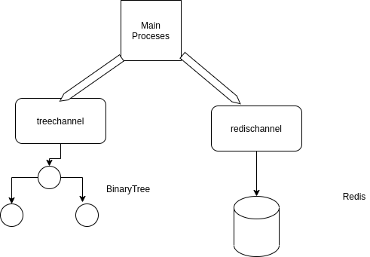

* Create a kafka screen that write data in kafka channel if order match each other (Optional)